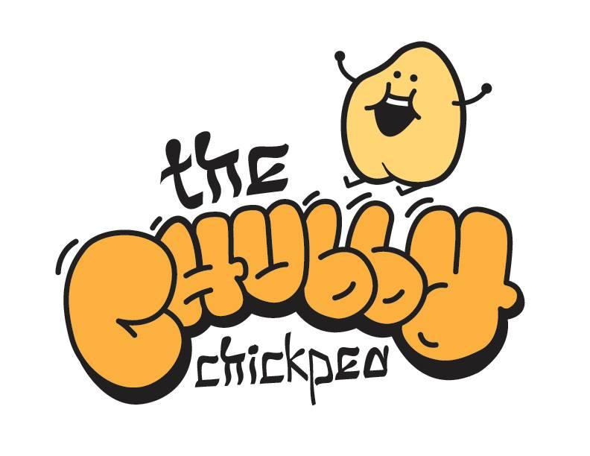
How To Order:
Email: Catering@TheChubbyChickpea.com
Call: 781.828.6868
When possible, we ask for at least 24 hours notice for catering orders. Delivery outside of Canton, MA has a delivery fee of $30. All orders will be delivered within the provided 15 minute delivery window, with paper goods. Deluxe Make Your Own Pita Bar options are not available for parties of less than 80. Payment is required prior to delivery.
Sandwich Platters
Sandwich Choices Include:
House Smoked Brisket, House Roasted Turkey, House made Mozzarella Caprese, Marinated Portobello Mushroom, Smoked Roast Beef.
Bread Choices Include:
Rye, Wheat, White, French Roll, Bulky.
Condiments Include:
House made honey mustard, House made yellow mustard, garlic aioli, basil pesto, zhoug, mayonaiise.
-Basic includes choice of one meat sandwich options and one vegetarian sandwich option. 2 condiments. $7.99 p/p
-Meaty includes all three of our meat sandwich options. 3 condiments. $9.99 p/p
-Deluxe Includes all of our sandwich options and all of our condiments. $11.99 p/p

Salads
Greek Salad $2.99 p/p
Mixed greens, pepperoncini, kalamatta olives, cucumbers, red onions and cherry tomatoes. House vinagraitte. Feta on the side.
Traditional Garden $1.99 p/p
Mixed greens, cucumbers, tomatoes, red onions, house bleu cheese or vinagraitte. House croutons.
Chickpea Salad $1.99 p/p
Chickpeas, cucumbers, dill, red onion, red pepper. Over greens.
Make Your Own Pita Bars
Sandwich Choices Include:
Falafel, Chicken Shawarma, Grilled Eggplant, Chicken Schnitzel, Yemenite Fried Chicken +3, Grilled Chicken, Smoked Lamb +5
All sandwiches bars comes with imported Israeli pita.
Condiments Include:
Red Zhoug, Green Zhoug, Tahini, Green Tahini, Mango Sauce, Tzaziki.
-Basic includes choice of one meat sandwich options and one vegetarian sandwich option. 2 condiments. $7.99 p/p
-Meaty includes three of our meat sandwich options. 3 condiments. $9.99 p/p
-Deluxe Includes all of our sandwich options and all of our condiments. $11.99 p/p

Sides and Salads
Israeli Fried Rice $2.99 p/p
Saffron Rice $1.99 p/p
Vegetable Couscous $1.99 p/p
Beef Broth Couscous $2.99 p/p
Hummus $1.99 p/p
Pita $1.99 p/p
Babaganouj $2.99 p/p
Moroccan Carrots $1.99 p/p
Pumpkin Babaganouj $3.99 p/p
Eggplant Salad $2.99 p/p
Dukkah Beets $4.99 p/p
Tabouleh $2.99 p/p
Chickpeas & Kale $3.99 p/p

Desserts & Drinks
Baklava $2.99 p/p
Rugelach $1.99 p/p
H20 $1.99 p/p
Assorted 20oz Soda $2.99 p/p

